Instructions for enabling Macro functions for Rule 1401 Excel Spreadsheets

The macro functions have been disabled if there is a Security Warning message as shown upon opening a file:
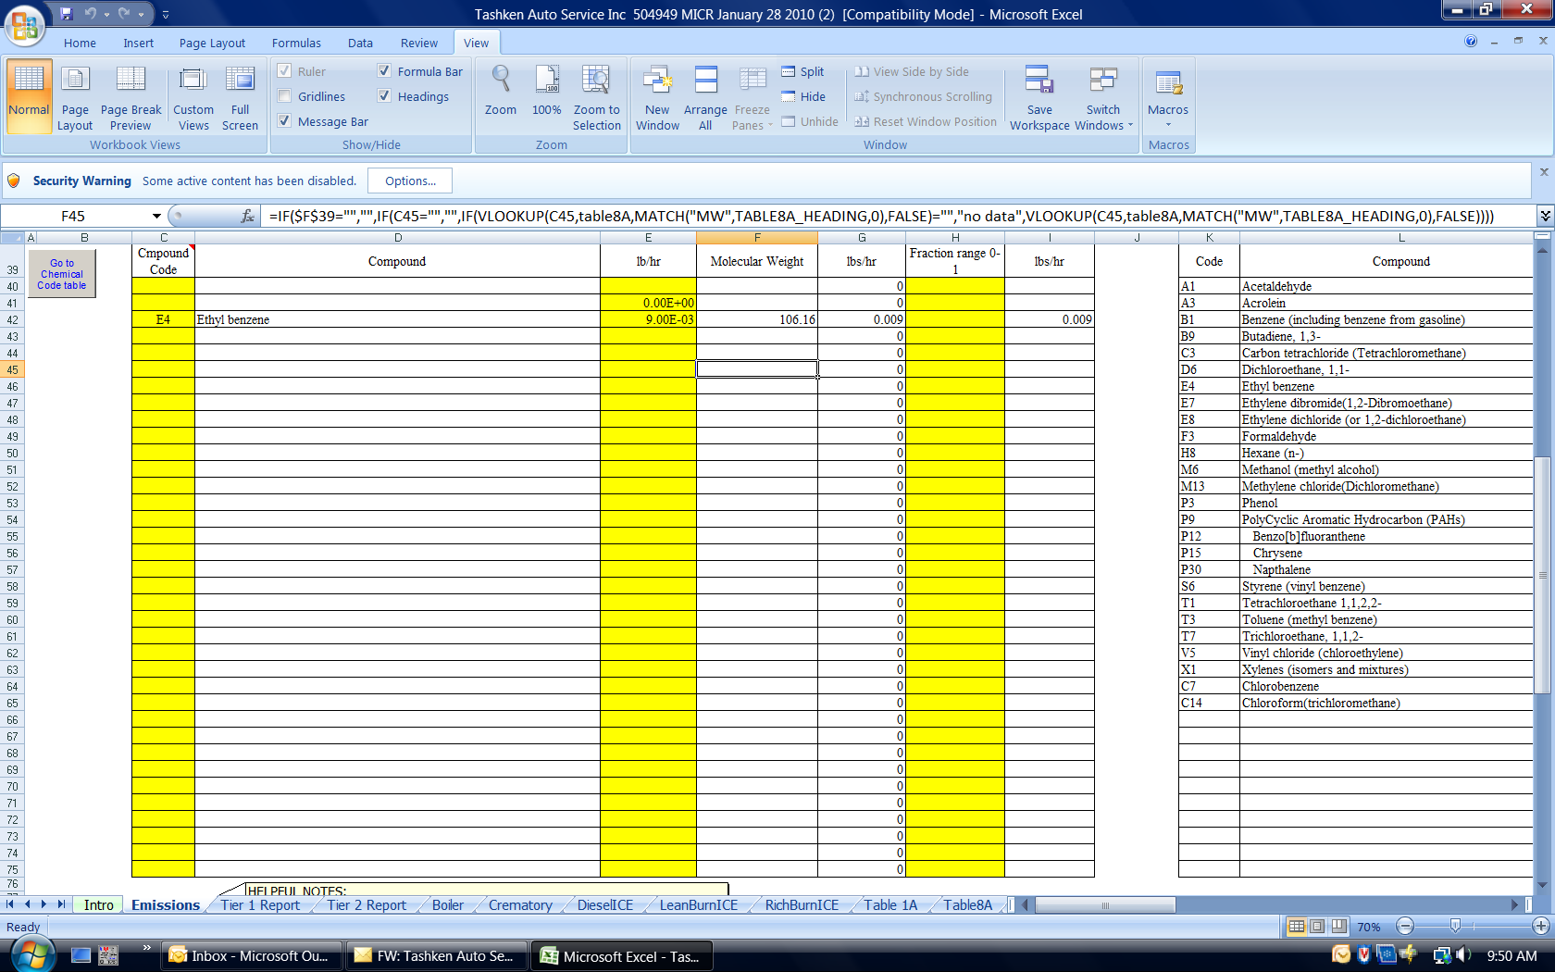

Or if calculations fail as shown below on the Tier 2 Report worksheet:
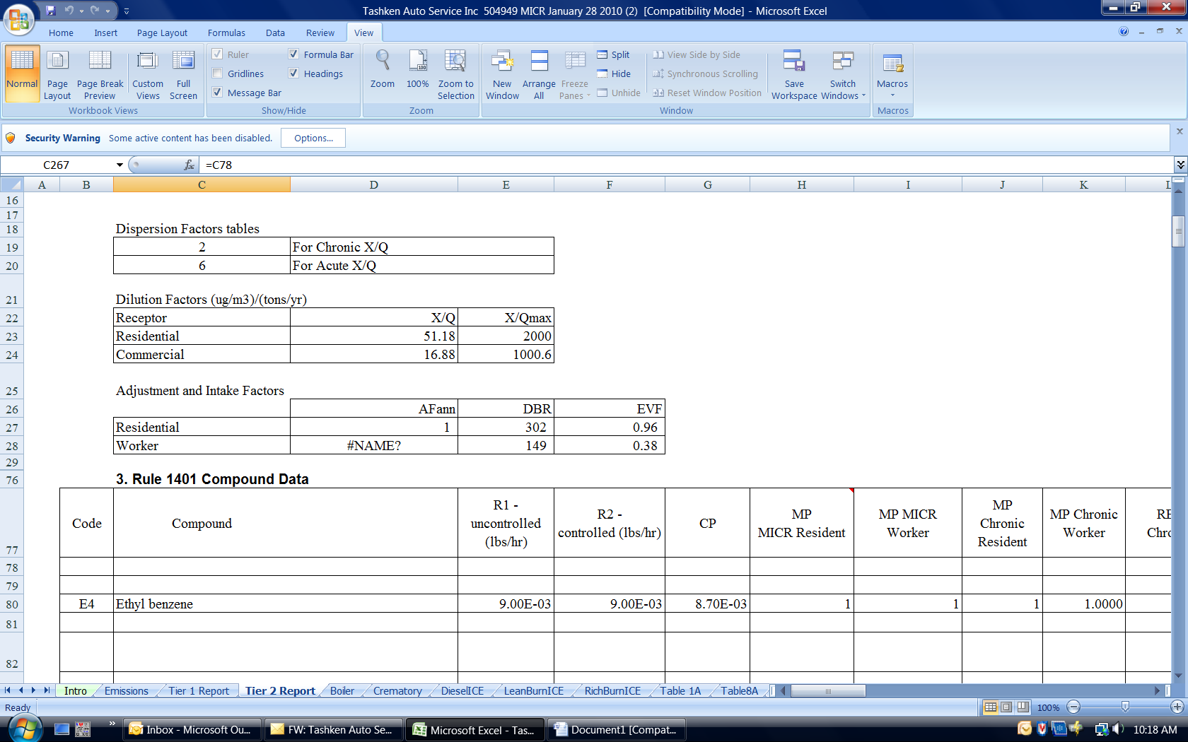

Macros may be enabled for individual worksheets or for all worksheets.
Steps to enable macros for an individual (active) worksheet:
- Choose Options next to the Security Warning.
- Choose Enable this Content.
- Choose OK.
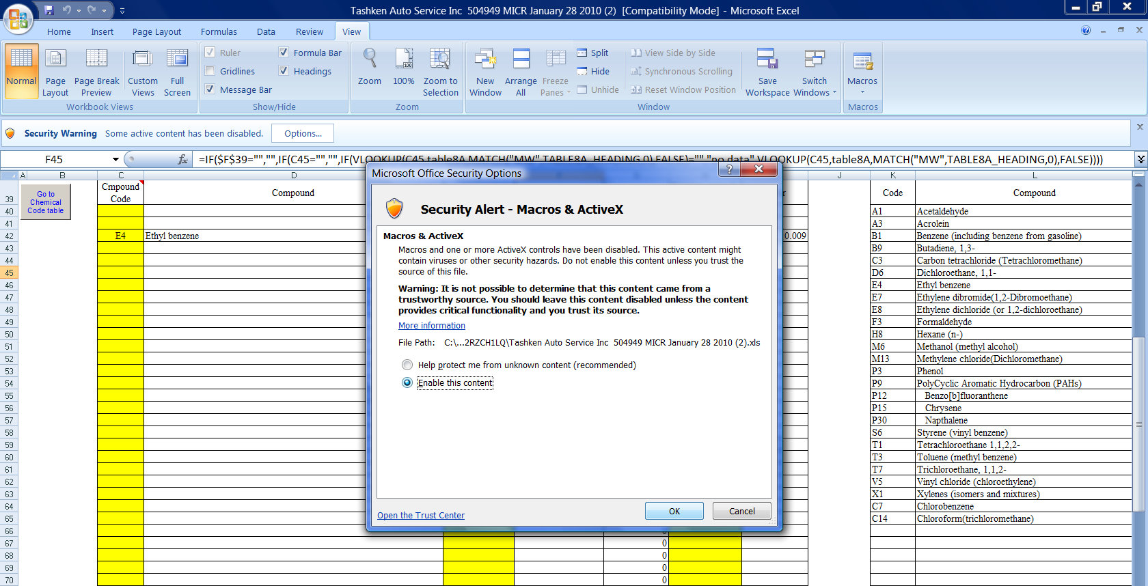
Steps to enable Macros for all worksheets:
- Click Office Button in Excel and choose Excel Options.
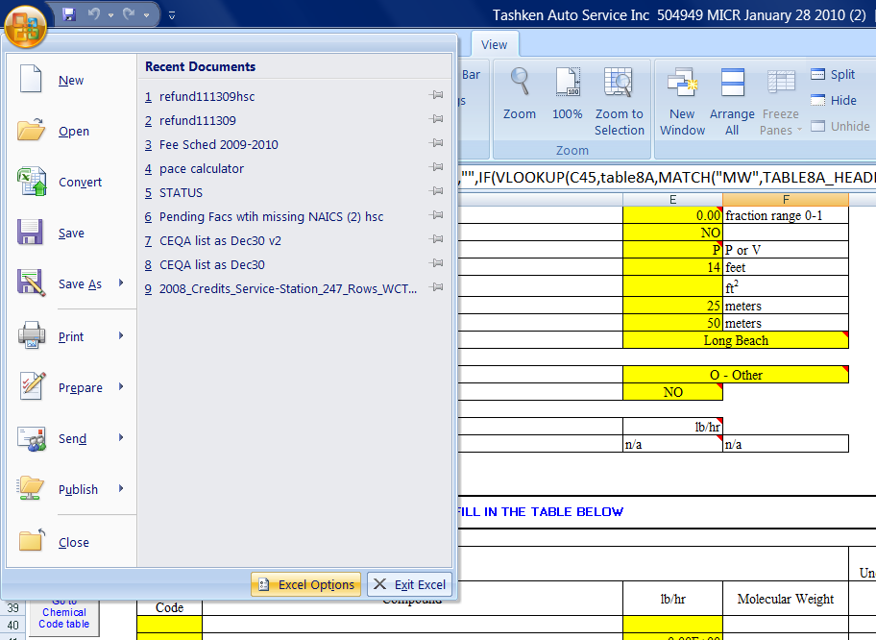
- Click on Trust Center Settings in the menu on left hand side. Then click on Trust Center Settings.
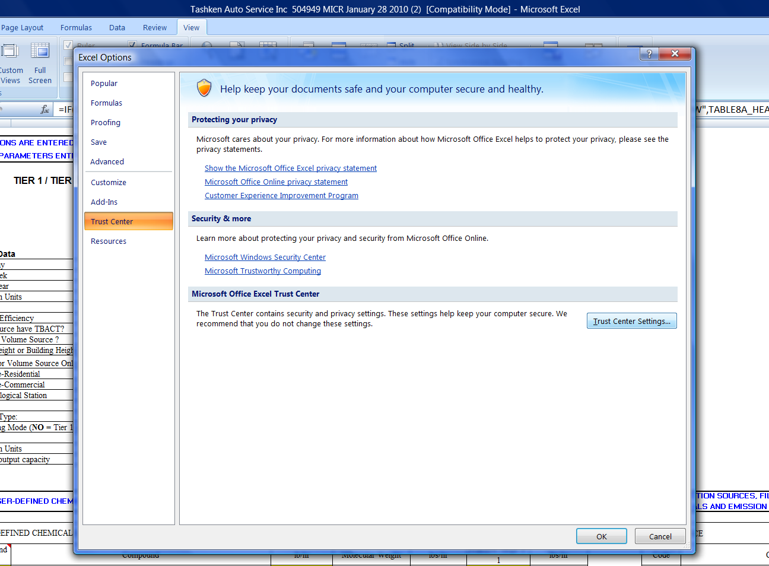
- Click on Macro Settings in the menu on left hand side. Then choose Enable all macros. Choose OK. You will need to click on OK again upon returning to the Excel Options screen.
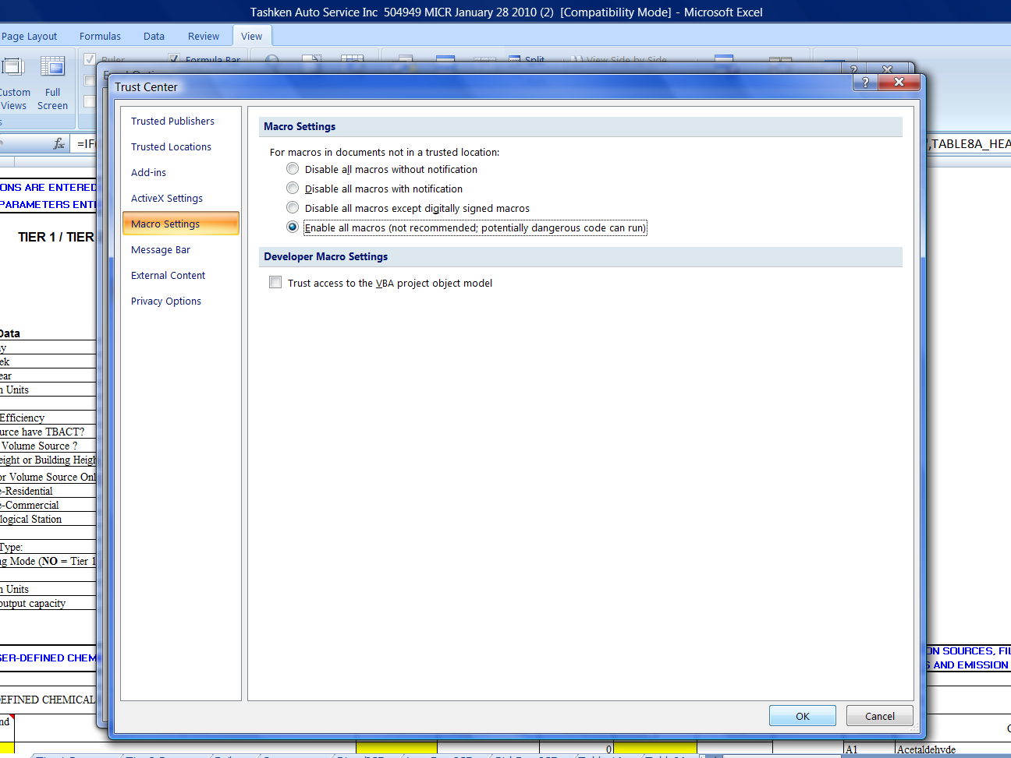
Close the Excel file and reopen to apply new settings. To ensure that Macros are working, click on Tier 2 Report worksheet tab and check calculations.

