

FOR IMMEDIATE RELEASE: May 2, 2026
MEDIA CONTACT:
Nahal Mogharabi: (909) 396-3773, Cell: (909) 837-2431
Rainbow Yeung: (909) 396-3373, Cell: (909) 967-2477
press@aqmd.gov

South Coast AQMD Issues Windblown Dust Advisory for the Coachella Valley
Valid Sunday 4 PM through Monday 11:59 PM

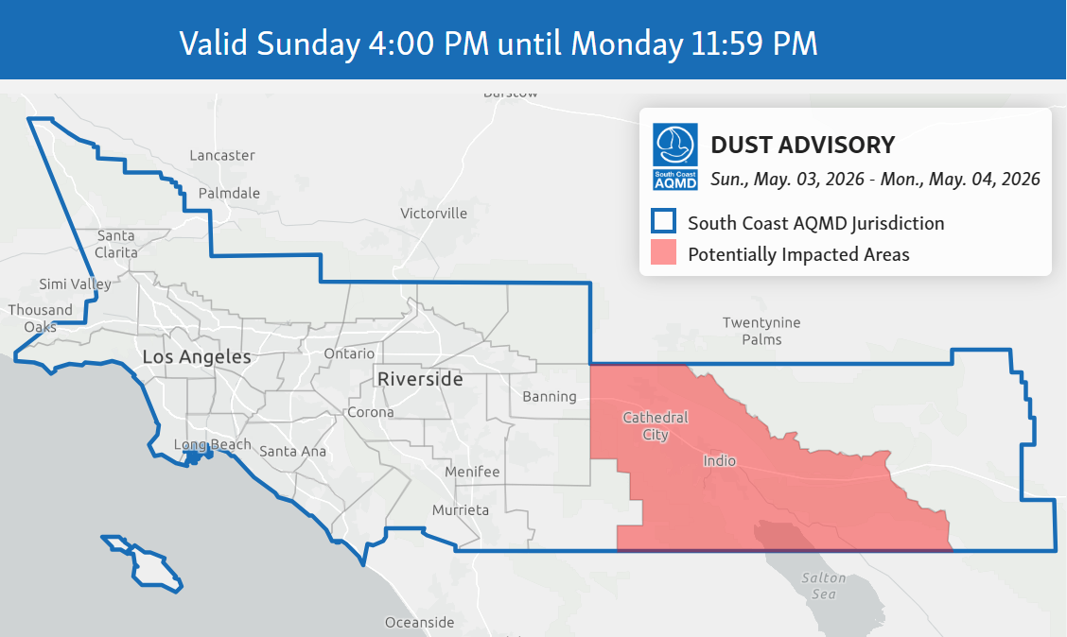

Forecasted Air Quality Impacts

- Windblown dust and high particle pollution (PM10) in the Unhealthy or higher air quality index (AQI) categories are expected at times from 4 PM Sunday through late Monday night in the Northern Coachella Valley, while other areas of the Coachella Valley will experience Unhealthy for Sensitive Groups or higher AQI categories during this time.
- Windblown dust is due to high winds with gusts up to 40-50 mph that are expected through Monday night in the Northern Coachella Valley. Elsewhere, winds will gust to 30 mph.

To view current air quality in your neighborhood, download the South Coast AQMD app or visit www.aqmd.gov/AQImap.

Detailed Forecast

Sunday evening through Monday Morning | Starting from 4 PM Sunday to 7AM Monday, Unhealthy or higher AQI is expected at times in the Northern Coachella Valley and Unhealthy for Sensitive Groups in other areas of the Coachella Valley
Monday daytime | Wind speeds are predicted to decrease a little during daytime. Expect Moderate to Unhealthy for Sensitive Groups AQI levels.
Monday evening and night | Wind speeds are expected to increase again after 3 PM Monday in the Coachella Valley. Unhealthy or higher AQI's are expected at times in the Northern Coachella Valley and Unhealthy for Sensitive Groups in other areas of the Coachella Valley.

South Coast AQMD will issue an update if additional information becomes available.

If you are in an area impacted by windblown dust:

- Limit your exposure by remaining indoors with windows and doors closed or seeking alternate shelter.
- Avoid vigorous physical activity.
- Run your air conditioning and/or an air purifier. If possible, do not use swamp coolers or whole house fans that bring in outside air.
- Help minimize dust pollution by stabilizing loose soils and slowing down if driving on dirt roads.

For more information, see the EPA Guide for Particle Pollution (PDF).

South Coast AQMD is the regulatory agency responsible for improving air quality for large areas of Los Angeles, Orange, Riverside and San Bernardino counties, including the Coachella Valley. For news, air quality alerts, event updates and more, please visit us at www.aqmd.gov, download our award-winning app, or follow us on Facebook, X (formerly known as Twitter) and Instagram.

# # #

